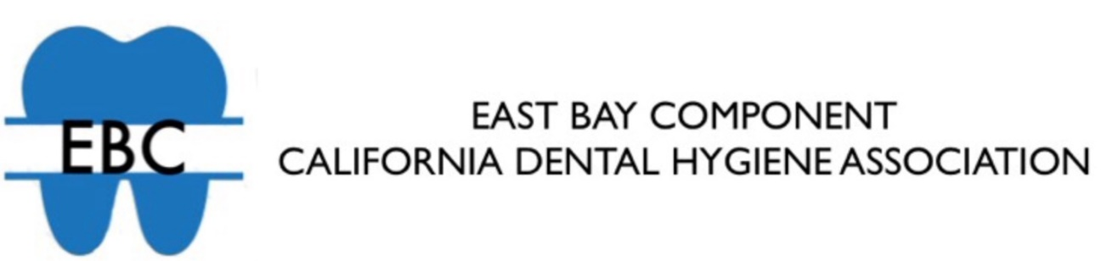
ANNE SCHWEIKERT/EAST BAY COMPONENT STUDENT AWARD
The Anne Schweikert/East Bay Component Student Award is awarded annually at the Chabot College Dental Hygiene Program Graduation Ceremony by the EBC Student Liaison Officer. The award covers the cost of one year membership in the California Dental Hygienists’ Association as well as the East Bay Component. Each year, the award is presented to a second year Dental Hygiene student.
The following criteria is used to select a recipient.
1. Prior to receiving the award, the student must have been an active participant in Chabot College’s Student Member of the California Dental Hygienists’ Association.
2. The recipient must have demonstrated leadership qualities as a student.
3. Once receiving the award, the student must agree to participate on the EBC Board as an assistant to the East Bay Component Student Liaison Officer.

Deadline for applications is April 14th.
Please mail the applications to:
EBC - ℅ Tresa Irby
4176 Omega Avenue
Castro Valley, CA 94546

